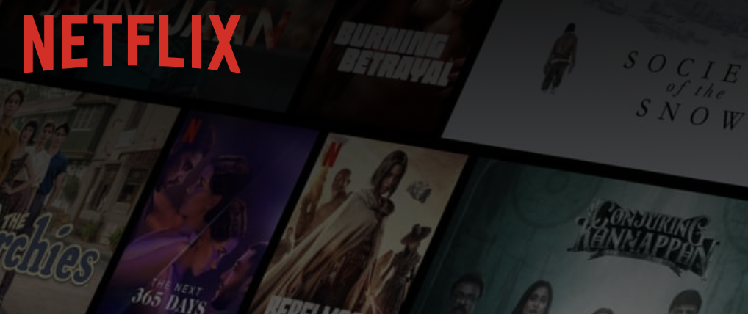

**Product Dissection for Netflix**

### **Company Overview:**

Netflix, founded in 1997 by *Reed Hastings* and *Marc Randolph*, has transformed the way people watch TV and movies. With its innovative subscription-based streaming service, Netflix has made it possible for people to watch TV shows and movies on their schedule, on any device, and without any commercials.

Acquired by no one, Netflix has remained independent and has grown to become the world's leading streaming service, with over 220 million subscribers in over 190 countries. Netflix is known for its wide variety of content, including original TV shows and movies, licensed TV shows and movies, and documentaries.

Netflix has also been a pioneer in the field of personalized recommendations. Using machine learning, Netflix recommends TV shows and movies to users based on their viewing history and preferences. This has made it easier for users to discover new content that they will enjoy.

Netflix is a successful company that has revolutionized the way people watch TV and movies. It has also had a major impact on the entertainment industry. Netflix is well-positioned to continue to grow and innovate in the years to come.

**Product Dissection of Netflix:**

Netflix, A global streaming giant, has revolutionized the way people watch TV and movies, effectively addressing real-world challenges through its innovative product offerings. Netflix is a subscription-based streaming service that allows users to watch TV shows and movies on a variety of devices, including TVs, computers, smartphones, and tablets. Netflix offers a wide variety of content, including original TV shows and movies, licensed TV shows and movies, and documentaries.

**Netflix's key features include:**

* **Subscription-based model:** Users pay a monthly subscription fee to access all of Netflix's content.
* **On-demand viewing:** Users can watch what they want, when they want, without commercials.
* **Wide variety of content:** Netflix offers a wide variety of TV shows, movies, and documentaries from around the world.
* **Personalized recommendations:** Netflix uses machine learning to recommend TV shows and movies to users based on their viewing history and preferences.
* **Offline viewing:** Users can download TV shows and movies to their devices for offline viewing.

**Case Study:**

Let’s understand how Netflix has made an impact on people’s lives through an example.

**Example:**

Laxmi is a young woman who lives in a rural village in India. She has always wanted to watch TV shows and movies from other countries, but she didn't have access to cable or satellite TV. Her internet connection was also slow and unreliable.

When Netflix launched in India, Laxmi was excited to finally have a way to watch her favourite TV shows and movies. She subscribed to Netflix and was able to start watching TV shows and movies from all over the world.

Laxmi says that Netflix has changed her life. It has allowed her to experience new cultures and learn about new things. She is also able to connect with other people who share her interests, regardless of where they live in the world.

**Conclusion:**

Netflix is a case study of how a company can use technology to solve real-world problems. Netflix has made TV shows and movies more accessible to people around the world, regardless of their location or income level.

Netflix has also had a positive impact on culture and society. It has made it easier for people to learn about different cultures and connect with others who share their interests.

**Impact:**

Netflix has had a major impact on people in developing countries. It has given them access to a vast library of TV shows and movies at an affordable price. Netflix has also helped to promote cultural understanding and appreciation by making it easier for people to watch TV shows and movies from other countries.

### **Real-World Problems and Netflix’s Innovative Solutions:**

**Problem 1: Limited access**

**Challenge:** If you don't have access to a variety of TV shows and movies, you may be forced to watch what's on, even if you're not interested in it.

**Solution:** Netflix offers an affordable streaming service with a wide variety of TV shows and movies, including original content, in over 190 countries. This has given people in developing countries access to a vast library of content at an affordable price and helped to promote cultural understanding and appreciation. Netflix is also investing in those countries and promoting their culture and language worldwide.

**Problem 2: Expensive**

**Challenge:** Cable and satellite TV can be expensive, especially if you have a lot of channels and you only watch a few channels regularly. This can make it difficult to justify the cost.

**Solution:** Netflix addressed the issues of the high cost of entertainment throughout the world and came up with the solution of providing a more affordable alternative to cable and satellite TV, which can cost thousands of rupees per month. This solution has made it easier for people to save money on their entertainment expenses.

**Problem 3: Inconvenient TV viewing experience**

**Challenge:** Traditional TV networks air their shows on a set schedule, which can be inconvenient if you have a busy schedule or if you want to watch a show at a different time.

**Solution:** Netflix allows users to watch TV shows and movies on their schedule, without having to wait for them to air on TV. You can also pause, rewind, and fast-forward content as needed. This is especially beneficial for people with busy schedules or who want to avoid commercials.

**Problem 4: Content discovery**

**Challenge: Searching for new and distinct TV shows and movies is challenging work for movie enthusiasts.**

**Solution: Netflix uses machine learning** to recommend TV shows and movies to users based on their viewing history and preferences. This helps users to discover new content that they are likely to enjoy. According to a study by McKinsey & Company 75% of users end up watching Netflix's recommendations on the platform.

**Problem 5: Lack of representation**

**Challenge:** Traditionally, the entertainment industry has been dominated by a limited group of people. This has led to a lack of representation for people of colour, women, and other talented artists.

**Solution:** Netflix is investing heavily in original content that features diverse casts and crews. This is helping to promote representation in the entertainment industry and to provide viewers with more diverse content choices. Netflix's original content has been very successful. Some of its most popular original shows, such as "Orange Is the New Black" and "Stranger Things" feature diverse casts and crews. Netflix's original content has had a positive impact on the entertainment industry. It is helping to promote representation and to provide viewers with more diverse content choices.

**Conclusion:**

Netflix's journey from a DVD-by-mail service to a global streaming giant is a testament to its ability to identify real-world problems and provide innovative solutions. By offering a convenient and affordable way to watch TV shows and movies on demand, Netflix has solved several problems for its users. Netflix's innovative solutions to real-world problems have had a positive impact on people around the world. The company has made it easier for people to watch the content they want, save money on their entertainment expenses, and have a more convenient and enjoyable TV viewing experience.

**Top features of Netflix:**

* **Wide variety of content:** Netflix offers a vast library of TV shows and movies from around the world. This includes original content, licensed content, and documentaries. You can filter content according to genre such as Thriller, Action, Adventure, Science-Friction, Fantasy, Drama, International, etc. Apart then this you can also search by different languages, English, Hindi, and Korean names to name a few.
* **Personalized recommendations:** Netflix uses machine learning to analyse a user's viewing history and preferences to recommend TV shows and movies that they are likely to enjoy. This feature makes it easy for users to discover new content that they may not have found on their own. For example, if a user has watched a lot of documentaries about nature, Netflix might recommend other documentaries about nature, as well as TV shows and movies about nature.
* **Offline viewing:** Netflix allows users to download TV shows and movies to their devices for offline viewing. This is a convenient feature for people who want to watch content when they don't have an internet connection, such as when they are travelling or commuting.
* **No advertisement:** Netflix is an ad-free streaming service. Users can watch their favourite TV shows and movies without being interrupted by commercials, that too while opting for their lowest monthly plan. Whereas, in Disney+ Hotstar you have to watch a 15-30-second advertisement. This is a significant advantage over other platforms (*as of now*), which often air multiple commercials per hour.

*\*\** *As of September 2023, Netflix only offers ad-supported plans in select countries, including the United States, Canada, the United Kingdom, and Australia \*\**

* **No additional charges:** Netflix's transparent pricing is one of its key features. Users know exactly how much they will be paying each month, and there are no additional charges. Whereas, in Prime Video offered by Amazon you have to pay extra charges other than the monthly plan, if you want to stream new movies or to avail video-on-demand option.
* **Multiple profiles:** Netflix allows users to create multiple profiles for their account, so each member of their household can have their own personalized viewing experience. This feature is useful for families with children or for people who share their Netflix account with roommates.

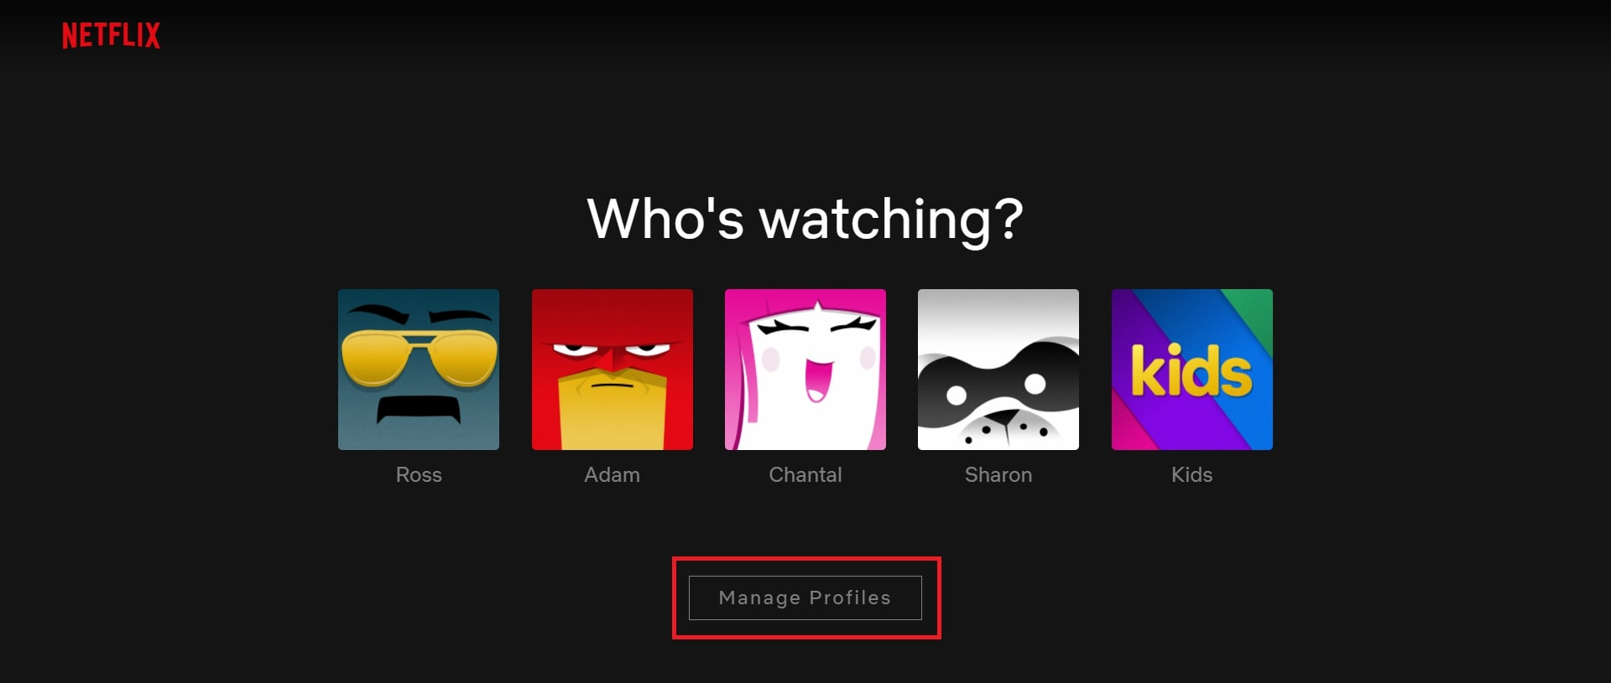

* **Parental control:** With internet accessibility now becoming very easy for all age groups, it is essential to monitor and control what people of some age groups might watch. Many parents might want parental controls on certain content available on the Netflix mobile app, considering most kids these days have a smartphone. One of the best features of Netflix is precisely to address this concern. It allows parents to control what their kids watch with four different content maturity levels, from “little kids” to “all.” You can also provide a security PIN, which is part of the “Parental Controls” section in the “General Settings.

**Schema Description:**

Schema Description The schema for Netflix involves multiple entities that represent different aspects of the platform. These entities include Users, Profiles, Watchlists, Ratings, Reviews, Payment Methods, Addresses, Transactions, and Subscriptions for User Management. Each entity has specific attributes that describe its properties and relationships with other entities.

Below is a **detailed ER diagram for User management:**

**User Entity: Represent a Netflix user.**

* **user_id:** A unique identifier for each user. **(Primary Key)**
* **username:** full name of the user.
* **email**: The user's email address for account-related communication.
* **registration_Date**: The date when the user joined Instagram.
* **password:** Secret code to log into a user account.
* **phone_number:** The user’s phone number.

**Profile Entity:** Represents a user’s profile on Netflix.

* **profile_id:** The user’s unique profile identification**. (Primary Key)**
* **user_id:** A unique identifier for each user. **(Foreign Key)**
* **profile_name:** The user’s profile name.
* **language:** The user’s preferred language.

**Watchlist Entity:** Represents a list of content a user wants to watch later.

* **watchlist_id:** The user’s unique watchlist identification**. (Primary Key)**
* **user_id:** A unique identifier for each user. **(Foreign Key)**
* **content_id:** A unique identifier for each content **(Foreign Key)**
* **added_date:** Date when content is added to the watchlist.

**Rating Entity:** Represents a user's rating for a piece of content.

* **rating_id:** A unique identifier for each rating. **(Primary Key)**
* **user_id:** A unique identifier for each user. **(Foreign Key)**
* **content_id:** A unique identifier for each content **(Foreign Key)**
* **rating:** Rating out of 5 for each content.

**Review Entity:** Represents a user's rating for a piece of content.

* **review_id:** A unique identifier for each review. **(Primary Key)**
* **user_id:** A unique identifier for each user. **(Foreign Key)**
* **content_id:** A unique identifier for each content **(Foreign Key)**
* **review_text:** A user’s comment for the content.

**Payment Method Entity:** Represents a user's payment method.

* **payment_method_id:** A unique identifier for payment method. **(Primary Key)**
* **user_id:** A unique identifier for each user. **(Foreign Key)**
* **card_number:** Credit or Debit card number.
* **expiration_date:** Expiry date of card.
* **billing_address:** User’s billing address.

**Address Entity:** Represents a user's billing or shipping address.

* **address_id:** A unique identifier for address. **(Primary Key)**
* **user_id:** A unique identifier for each user. **(Foreign Key)**
* **street_address:** User’s street address.
* **city:** User’s city address.
* **state:** User’s state address.
* **country:** User’s country.
* **zip/pin_code:** User’s zip/pin code.

**Transaction Entity:** Represents a financial transaction made by a user.

* **transaction_id:** A unique identifier for the transaction made. **(Primary Key)**
* **user_id:** A unique identifier for each user. **(Foreign Key)**
* **payment_method_id:** A unique identifier for payment method. **(Foreign Key)**
* **amount:** amount paid by the user.
* **date:** date of transaction.

**Subscription Entity:** Represents a subscription service choice of a user.

* **subscription_id:** A unique identifier for subscription service. **(Primary Key)**
* **user_id:** A unique identifier for each user. **(Foreign Key)**
* **subscription_type:** Monthly or **yearly subscription**
* **plan_type:** Plan according to device (mobile, basic, standard, premium)
* **price:** Amount according to subscription and plan type.

**Relationship are:**

**User:**

* has many profile (1:M)
* has one or more Watchlists (1:M)
* gives many Rating (1:M)
* writes many Reviews (1:M)
* has many Payment Methods (1:M)
* has many Addresses (1:M)
* has many Transactions (1:M)
* has one Subscription (1:1)

**Profile:**

* can have one or more Watchlists (1:M)
* can write many Reviews (1:M)
* can give many Rating (1:M)
* can have many transactions (1:M)

**Watchlist:**

* belongs to one User (M:1)

**Rating:**

* belongs to one User (M:1)
* belongs to one Content (M:1)

**Review:**

* belongs to one User (M:1)
* belongs to one Content (M:1)

**Payment Method:**

* belongs to one User (M:1)

**Address:**

* belongs to one User (M:1)

**Transaction:**

* belongs to one User (M:1)
* belongs to one Payment Method (M:1)

**Subscription:**

* belongs to one User (1:1)

*\*\*here (1:M), (1:1), and (M:1) represents one-to-many, one-to-one, and many-to-one respectively\*\**

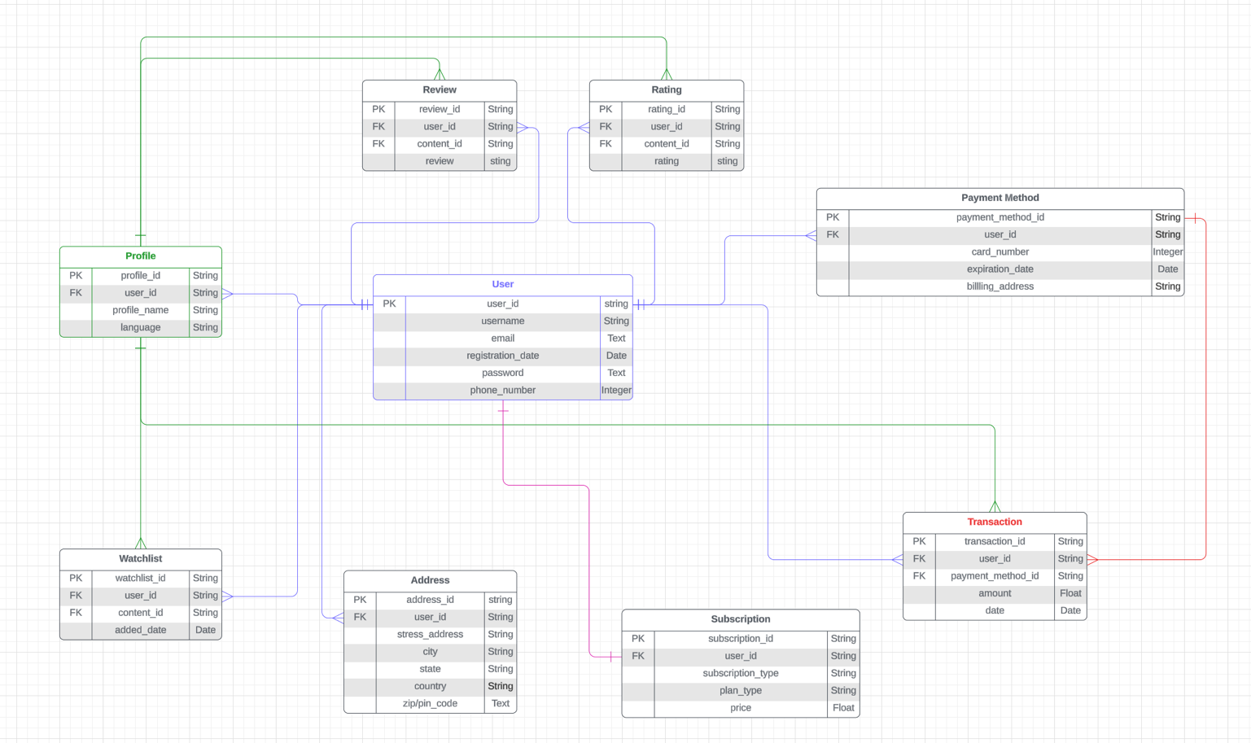**ER Diagram for User Management**

**Schema Description:**

The schema for Netflix involves multiple entities that represent different aspects of the platform. These entities include Content, Episode, Season, Genre, Language, Director, Writer, Actor/Actress, and Studio for Content Management. Each entity has specific attributes that describe its properties and relationships with other entities.

Below is a **detailed ER diagram for Content management:**

**Content Entity:** Represent a piece of content on Netflix (movie, TV show, documentary, etc.

* **content_id:** A unique identifier for each content **(Primary Key)**
* **type: Like movies, TV shows, documentaries, etc.**
* **title:** Name of the content.
* **release_year: Year in which content was released.**
* **episode_number: Number of episodes if available.**
* **runtime: Duration of the content.**
* **description:** Little summary of the content
* **language_id:** A unique identifier for each language **(Foreign Key)**
* **director_id:** A unique identifier for each director **(Foreign Key)**
* **writer_id:** A unique identifier for each writer **(Foreign Key)**
* **cast_id:** A unique identifier for each actor/actress **(Foreign Key)**
* **studio_id:** A unique identifier for each studio **(Foreign Key)**

**Episode Entity:** Represents an episode within a TV show season.

* **episode_id:** A unique identifier for each episode **(Primary Key)**
* **content_id:** A unique identifier for each content **(Foreign Key)**
* **season_id:** A unique identifier for each season **(Foreign Key)**
* **season_number: Number of seasons content has.**
* **episode_number:** Number of episode content has.
* **release_date: Date on which content was released.**
* **title: Name of the content.**
* **runtime: duration for each episode.**

**Season Entity:** Represents a season within a TV show.

* **season_id:** A unique identifier for each season **(Primary Key)**
* **content_id:** A unique identifier for each content **(Foreign Key)**
* **season_number: Number of seasons content has.**
* **release_date: Date on which content was released.**
* **number_of_episodes: Number of episodes in each season.**

**Genre Entity: represents a genre associated with content.**

* **genre_id:** A unique identifier for each genre **(Primary Key)**
* **genre_name:** Name of the genre.

**Language Entity: Represents the language of the content.**

* **language_id:** A unique identifier for each language **(Primary Key)**
* **language_name:** Name of the language in which content is available.

**Director Entity: Represents a director who directed content.**

* **director_id:** A unique identifier for each director **(Primary Key)**
* **director_name: Name of the director.**

**Writer Entity:** Represents a writer who wrote content.

* **writer_id:** A unique identifier for each writer **(Primary Key)**
* **writer_name:** Name of the writer.

**Actor/Actress Entity:** Represents an actor or actress who appears in content.

* **cast_id:** A unique identifier for each actor/actress **(Primary Key)**
* **cast_name:** Name of actor or actress.

**Studio Entity:** Represents the studio that produced the content.

* **studio_id:** A unique identifier for each studio **(Primary Key)**
* **studio_name:** Name of the studio.

**Relationships are:**

**Content:**

* can have many Episodes (1:M)
* can have many Seasons (1:M)
* belongs to many Genres (M:N)
* is in many Language (M:N)
* is directed by one Director (M:1)
* is written by many Writers (M:N)
* features many Actor/Actress(M:N)
* is produced by one Studio (M:1)

**Episode:**

* belongs to one Content (M:1)
* belongs to one Season (M:1)

**Season:**

* belongs to one Content (M:1)

**Genre:**

* can be associated with many Contents (M:N)

**Language:**

* is associated with many Contents (M:N)

**Director:**

* directs many Contents (1:M)

**Writer:**

* writes many Contents (M:N)

**Actor:**

* can be featured in many Contents (M:N)

**Studio:**

* produces many Contents (1:M)

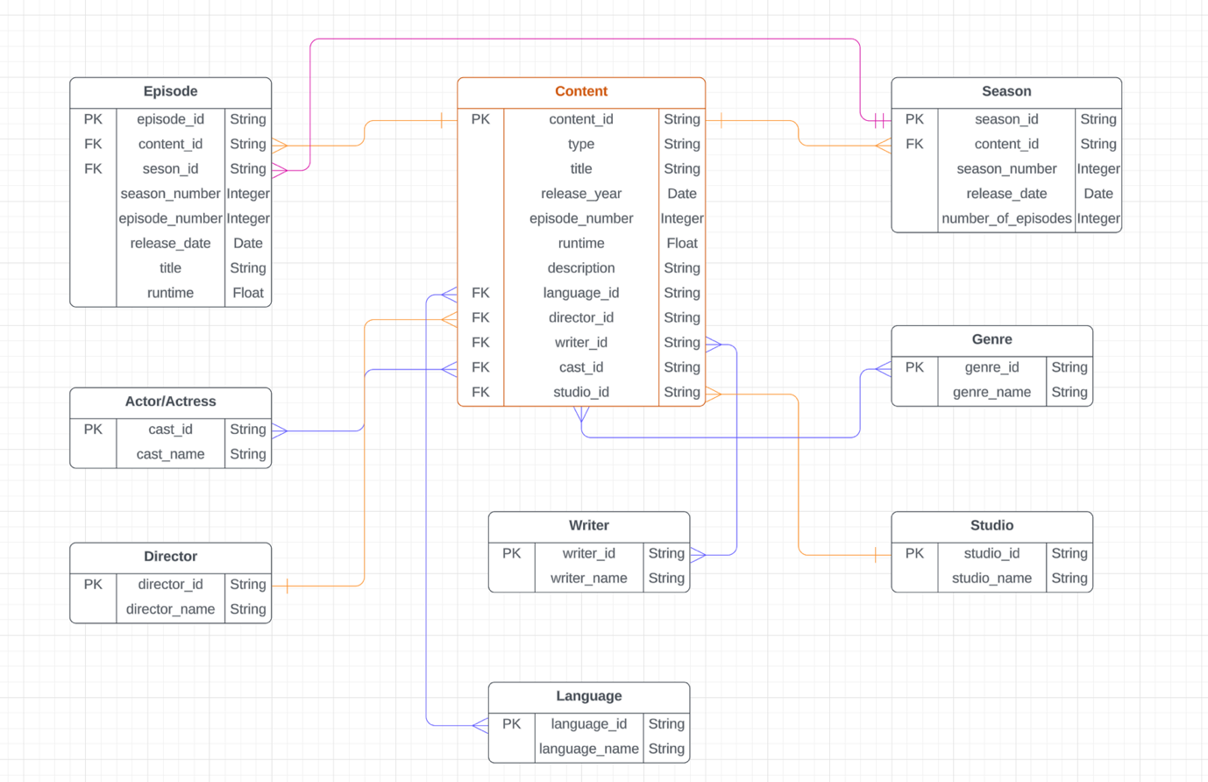

**ER Diagram for Content Management**

# **ER Diagrams Explanation**

ER diagrams, or Entity-Relationship diagrams, tell us a lot about the structure and relationships of data within a system or database. They are visual representations that use symbols to show:

**Entities:** These are the core data objects, like users, products, orders, etc. They are represented by rectangles in the diagram. **Attributes:** These are the individual characteristics of each entity, like username, product name, order date, etc. They are shown within the entity rectangles. **Relationships:** These connections show how entities interact with each other. Different line styles and symbols denote different types of relationships, such as one-to-one, one-to-many, and many-to-many.

**Conclusion:**

Netflix has redefined how we discover and enjoy entertainment. This exploration of its underlying data architecture, represented by the intricate tapestry of entities and relationships, has unveiled the secret sauce behind its captivating experience.

From the intricate web of content (movies, shows, documentaries) linked to genres, languages, studios, and creative talent, to the user profiles, subscriptions, ratings, and reviews, Netflix's schema reflects its deep understanding of its audience. This allows for personalized recommendations, tailored content discovery, and seamless streaming experiences that keep users glued to their screens.

By deconstructing this system, we appreciate the monumental task of managing massive user engagement, diverse content libraries, and the ever-evolving technology landscape. Netflix's dynamic data model, constantly adapting and innovating, ensures its continued relevance and dominance in the streaming wars.

This exploration serves as a reminder that captivating user experiences often rely on meticulously designed and constantly evolving data architectures. Netflix stands as a testament to the power of leveraging data efficiently to not only entertain but also forge connections, foster communities, and shape the future of entertainment itself.

**Skill Developed**

## **Skills Learned by Dissecting the Netflix Data Architecture**

Dissecting the Netflix data architecture, including its entities, relationships, and functionalities, taught me a valuable set of skills applicable to various technical and analytical domains. Here are some key takeaways:

**Technical Skills:**

* **Database Modeling:** I have gained hands-on experience in understanding and analyzing Entity-Relationship (ER) diagrams, a fundamental skill for designing and managing databases.
* **Data Analysis:** I have learned to identify and interpret relationships between different data entities, honing my ability to extract meaningful insights from complex datasets.
* **Data Querying:** Understanding the schema allows me to formulate effective queries to retrieve specific information from the database, a crucial skill for data scientists and analysts.

**Analytical Skills:**

* **Critical Thinking:** Deconstructing the system encourages me to think critically about its design choices, their impact on functionality, and potential areas for improvement.
* **Problem-Solving:** I have learned to identify potential issues or inefficiencies within the data architecture.
* **Strategic Thinking:** Analyzing how Netflix uses data to personalize user experiences and curate content can provide insights into broader strategic thinking about data-driven decision-making.
* **Communication Skills:** Effectively explaining your findings and insights about the data architecture requires clear and concise communication skills, valuable in any technical field.

**Additional Learnings:**

* **Industry Knowledge:** I have gained a deeper understanding of the challenges and opportunities specific to the streaming industry.
* **Project Management:** Dissecting a complex system like Netflix requires planning, organization, and research, transferable project management skills.

The process itself offers a valuable learning experience, equipping with technical, analytical, and problem-solving skills applicable across various domains.

**Created by: Pawan Rana**



** LinkedIn :** [**Pawan Rana**](https://www.linkedin.com/in/pawan-rana-33357b1b8/)

**Github :** [**Rana-Pawan**](https://github.com/Rana-Pawan)